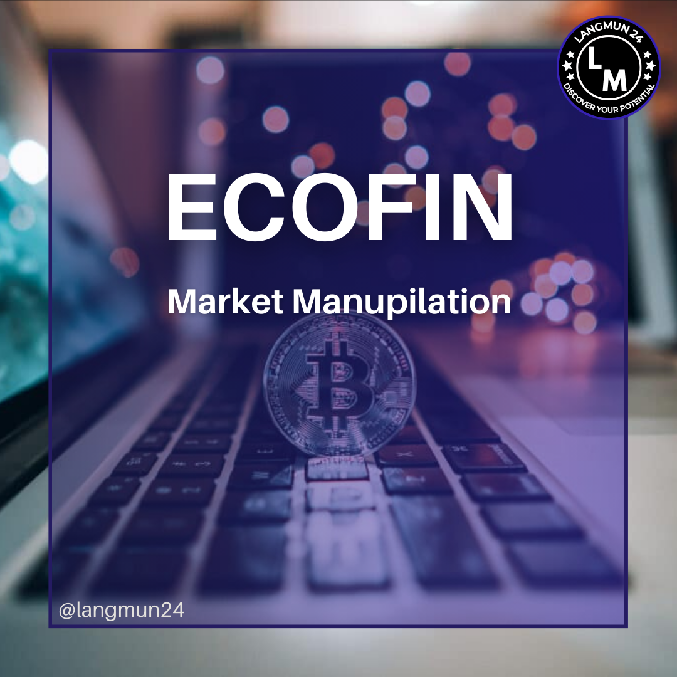

Conference: LANGMUN 24

Committee: Economic and Financial Affairs Council configuration (ECOFIN)

Agenda Item: Market Manupulation

**Table of Content**



**Letter from the Secretary General**

**1.0 Introduction to the Committee**

**1.1 Introduction to the agenda item**

**1.2 Ways of Market Manipulation**

**1.3 The Detection of Market Manipulation**

**2.0 Regulatory Responses and Preventive Measures**

**2.1 Questions to Ponder**

**Letter From Secretary-General**

**Most Esteemed Delegates of LANGMUN24,**

**I, as the Secretary General of LANGMUN24, am delighted to welcome you to the first iteration of Lang-Up Academy Model United Nations. I am pleased to present to you the fruits of our labour, which we have been preparing for several months. My team has worked tirelessly to deliver the best of unforgettable experiences that you will see for the first time in your city.**

**Our aim is to facilitate competent and high-level diplomatic negotiations,fostering valuable and constructive solutions throughout the two-day duration of LANGMUN, enriched by the collective contributions of all participants. As a delegate, your preparation for the event begins here, with the study guide prepared by our dedicated members;your most honorable chairboard.**

**I urge you to read this study guide thoroughly and to expand your research, focusing on your assigned country. Dig deeper,ask more questions and follow the path that your search engine of choice leads you down.**

**To conclude my words,you have my best wishes for success and enriched debates during these two days of enjoyment. I'm looking forward to witnessing the precious contributions you will make to our conference.**

**Best regards,**

**Nisa Naz Özdoğru**

**Secretary General of LANGMUN24**

**Introduction to the committee**

The Economic and Financial Committee, or ECOFIN, is the Second Committee of the United Nations General Assembly. ECOFIN grapples with questions of economic growth and development, including global macroeconomic policy, sustainable development, globalization, and the eradication of poverty.

**Introduction to the agenda item**

Market manipulation, also known as stock or price manipulation, is the general name for the artificial impact for the ongoing market value of a commodity, market, involving literal manipulation of the stock for financial gains illegally. Wrongfully influencing the efficiency, liquidity, integrity and development of the stock market. Market manipulating varies in kinds and has different ways of starting and growing. The main intend of it being to deceive investors by distorting natural supply and dynamics. Despite developments inn the financial market, these activities has shown a rapid increase over time and recent market fraud is the most severe issue facing global market integrities. Market and stock manipulation accounts 41% of overall fraud. Therefore making it a critical issue to be identified and prevented across all financial markets.

**Ways of Market Manipulation**

Market manipulation has different methods of occurring the common ones are pump and dump, wash trading, churning, spoofing, quote stuffing etc.

**The Pump and Dump method**

The pump and dump method is a manipulation scheme of stock that involves artificially raising the price of an item, a stock (the pump) through wrongful and frauding means. The main motivation behind it is quick profit and the low risk of detection. Followed by selling the pumped stock with the wrong, inflated price (the dump). This drops the actual price of the stock. The dump and dump method generally targets low-volume stocks, which is often penny stocks that are more open to manipulation.

The manipulator promotes the said stock by hyping it by media, channels, convincing people to mass buy. Or by spreading wrongful information about the stock. This can be exaggerated comments, misleading positive or negative information. Before this promotion, the manipulator buys a significant amount of the said stock at a low price and this establishes their position in the stock. As more investors buy in to the stock, the market price starters to inflate rapidly. This is the pump phase. As the prices raises to a satisfactory level, the manipulator starts selling the stock in hand with the inflated price. This is the dump phase. After the manipulator sells of their share and the hype dies, deflating the price, new investors are left with significant loss.

After the manipulator sells off their shares, the price typically crashes back down as the hype dissipates, leaving new investors with significant losses.

**The Wash Trading Method**

Wash trading occurs by an investor simultaneously buying and selling the same financial instrument to create false activity in the market. This is an illegal practive and is used to give the apperance that the said stocks trading volume has raised, falsely influencing other investors. It is highly motivated by tax benefits and improving perception. Wash trading is illegal under securities of laws. Regulatory bodies such as the SEC (Securities and Exchange Comission) in the US actively watches over ongoing trading activities to identify and punish. Individuals or firms that are charged guilty of trade washing can face fines, bans from the market and criminal charges.

**The Churning Method**

Churning involves frequent and excessive financial tradingthat arent aligned with the clients investment strategy. This action is done by brokers. A broker is a firm or individual that typically engages in the business of buying and selling stocks on the behalf of its customer and earns a part of the commission or other fees on each purchase of stocks that brokerage firm makes for the investor. This could include buying and selling the same security multiple times in a short period.

**The Spoofing Method**

Spoofing, also known as layering, is the action of placing a bid or an offer with no intention of fulfilling it and cancelling before the execution. The actual method of spoofing can vary. The immediate cancelling of the purchase can crate a false illusion of the price or its demand in the market of the relevant stock or security raising. The activity is typically short-term, as the spoofers take advantage of immediate market reactions to manipulate prices.

Spoofing can increase the unpredictability of the market and create chaos among traders leading to severe prive changes regarding the artificial demand of supplies. It erodes the stability of the financial market.

**The Detection of Market Manipulation**

Market manipulation can be detected before it has its consequences and different nations have improvised mutual methods on detecting it. Such as higher and securer surveillance systems. avoid the intends of the stock manipulation. Surveillance systems include a reporting system to capture daily positions of market participants exceeding a minimum threshold level. The surveillance systems strack the change in price or volume of particular stocks and securities, identify potential collusive or concerted activity by financial market participants and large market loss’ or gains incurred by firms trading for their own accounts. They are designed to keep the pace with the technological development and market evolution.

**Regulatory Responses and Preventive Measures**

Market manipulation being illegal has causes different nations to take different actions about the ongoing manipulative activities. Here is a few examples of regulations held in countries with high market value.

United States- Relies on the SEC (Security and Exchange Comission) to monitor over the market and detect abnormal activities and handle accordingly. The CFTC (Commodity Futures Trading Commission) also address’ and helps regulate U.S. markets

United Kingdom- The FCA (Financial Conduct Authority) holds its aims similar to the SEC, ensures market integrity and consumer protection. Monitors illegal market activites. The BoE (Bank of England) also has an oversight over certain markets and systemic risks.

Japan- Japan, having a well-established market teams with the FIEA (Financial Instruments and Exchange Act) is the main framework of the regulations.

China- CSRC (China Securities Regulatory Comission) is the main regulatory authority deployed for detecting market manipulation, siding with the PBoC (People’s Bank of China) while also depending on legal framework.

Germany- Relying mostly on the legal framework regarding the issue, the government of Germany prohibits the spreading of wrong information about the stock market. The EU aiming to keep the integrity of stock market stable.

India- As told, India also relies on the legal framework and national commissions. These being SEBI (Securities and Exchange Board of India) and the RBI (Reserve Bank of India) Individuals should also keep an eye on their status in the market. Understanding market dynamics and how markets operate plays a key role in preventing market manipulation. Being educated on trading strategies is crucial. Otherwise, being educated on manipulation tactics are even more important. Being aware of the common methods and detecting red flags help prevent stock manipulation easily. Trading activity should also be monitored and looking out for unusual patterns is major.

Avoiding penny stocks is also important. These stocks are more open for manipulation due to lower trading volume and liquidity.

**Questions to Ponder**

1. How can investors look out for stock manipulation?
2. How can stock manipulators be detected and sanctioned accordingly?
3. How can investors of firms get educated and look our for market manipulation?
4. How can market manipulation be overall stopped?
5. How market manipulation in interconnected markets affects other markets?